- Aiken-Lang STD Library Functions Test
rational.ak

Results:
pub fn mul(left: Rational, right: Rational) -> Rational {
let Rational { numerator: a_n, denominator: a_d } = left
let Rational { numerator: b_n, denominator: b_d } = right
Rational { numerator: a_n * b_n, denominator: a_d * b_d }
}

test mul_1() {
mul(ratio(2, 3), ratio(3, 4)) == ratio(6, 12)
}

test mul_2() {
mul(ratio(-2, 3), ratio(-3, 4)) == ratio(6, 12)
}

test mul_3() {
let result =
ratio(2, 5)
|> mul(ratio(1, 8))
|> mul(ratio(3, 10))
|> mul(ratio(21, 100))
|> mul(ratio(3, 5))
|> mul(ratio(2, 8))
|> mul(ratio(4, 10))
|> mul(ratio(22, 100))
|> reduce

result == ratio(2079, 50000000)
}
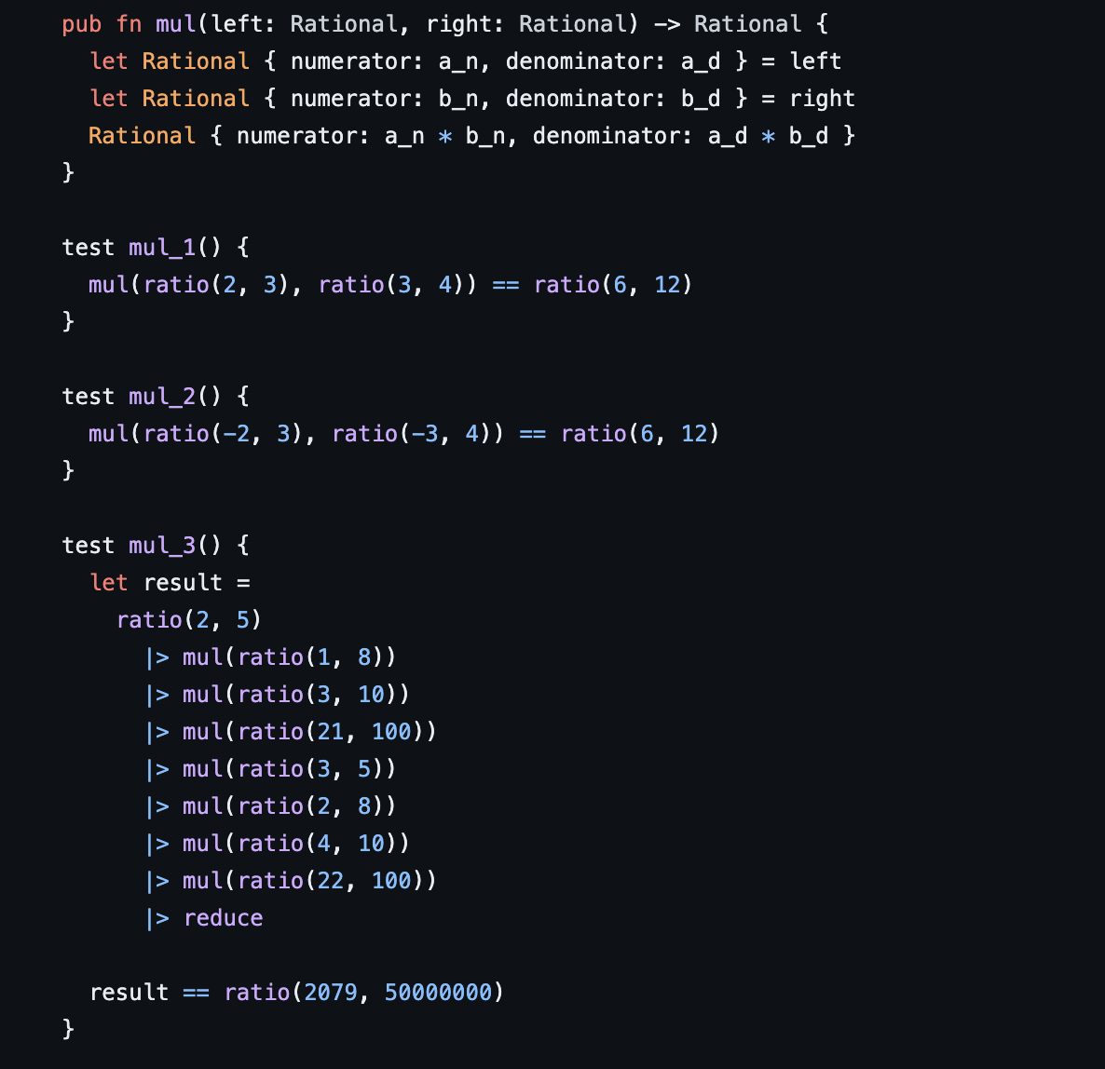
Tests:
test geometric_mean1() {
expect Some(x) = new(1, 2)
expect Some(y) = new(1, 2)
geometric_mean(x, y) == new(1, 2)
}

test geometric_mean2() {
expect Some(x) = new(-1, 2)
expect Some(y) = new(1, 2)
geometric_mean(x, y) == None
}

test geometric_mean3() {
expect Some(x) = new(1, 2)
expect Some(y) = new(-1, 2)
geometric_mean(x, y) == None
}

test geometric_mean4() {
expect Some(x) = new(1, 3)
expect Some(y) = new(1, 6)
geometric_mean(x, y) == new(1, 4)
}

test geometric_mean5() {
expect Some(x) = new(67, 2500)
expect Some(y) = new(35331, 1000)
expect Some(yi) = reciprocal(y)
geometric_mean(x, yi) == new(258, 9398)
}
